线上考试流程
1.教师下载企业微信和腾讯会议，注意 登录腾讯会议必须是企业账号登录。
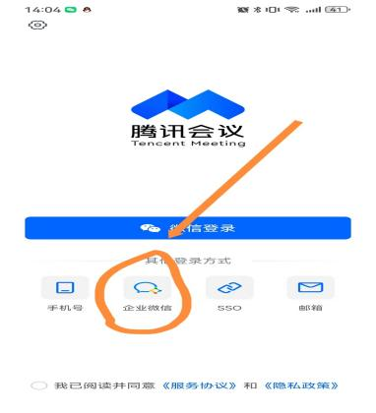
2.学生下载腾讯会议和钉钉
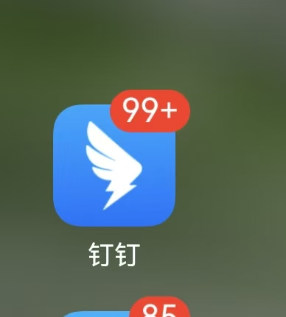
3教师预约腾讯会议时间后通过钉钉转发会议链接信息。注意考试前老师会让学生将摄像头环顾四周以确保考生一人在场以及无除考试需要外的其他电子产品。
4学生复制会议链接信息，打开手机腾讯会议即可参与。

Online exam process
For students，
First，they are required to download Tencent Meeting and DingTalk by March 12th.
Second ，Join the DingTalk group for the corresponding course. Please check the QR codes in the form or refer to attachment 2.
Third ，wait for the teacher’s DingTalk group messag. And Copy it to Tencent Meeting.

Exam rules:
1. Only international students stranded abroad can take the online exam (the background color in the form has been marked with yellow).Please check the QR codes in the form .

- Video surveillance will be adopted for the fixed-time online examination. The invigilating teachers and students should turn on the video camera. You can choose the following two modes：Computer + smart phone mode or Two smart phones mode. Computer or one smart phone is used for the examination platform login, test paper open, test group login and other purposes, the other smart phone for video surveillance. Please refer the following photo：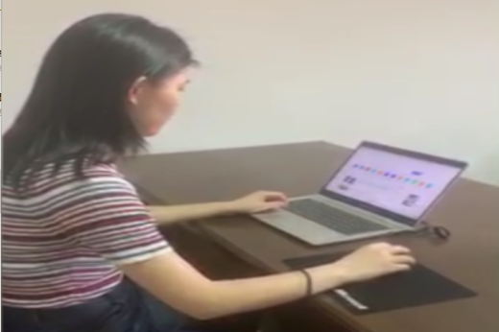
3.During an online exam, if a student experiences network disconnection, equipment failure, or other emergencies, the student is responsible for providing evidence. The student must contact the main examiner immediately to reach an agreement and keep all evidence.

Also，online students should prepare some blank A4 papers as answer-sheets or draft-sheets. Or you can check attachment 3 for soft copy of answer sheets and print out in advance.

浙江师范大学答题纸（线上考试）
ANSWER SHEET OF ZHEJIANG NORMAL UNIVERSITY（Online Examination）
课程名称(Course) ： 教学班号(Class Code：)：
考试时间 (Date) ： 2022年 (Y) 月 (M) 日(D) 时(H)至(to) 时(H)
期末考试(含前半期考试) 补缓考
Final Examination Make-up Examination & Delayed Examination
学院： 专业： 姓名： 学号：
(College) (Major) (Name ) (Student No.)
我承诺：自觉遵守考试纪律，独立完成答卷，切实维护考试的公正、公平。
I promise that I will abide by the exam rules and finish the paper independently to uphold the fairness and justice of the examination. 承诺人 ( Promiser) ：

题 号  PARTS | 一  I | 二  II | 三  III | 四  IV | 五  V | 六  VI | 七  VII | 八  VIII | 九  IX | 十  X | 总 分TOTAL
得 分
SCORE
阅卷人EXAM MARKER
请从此处开始作答：

